**AIM:**

Write a C program to find Fibonacci series using Recursion

***ALGORITHM***

• **Start**

• Read the number of terms n.

• If n <= 0, print *“Invalid input”* and **Stop**.

• Define a recursive function fibonacci(k) as:

* If k == 0, return 0.
* Else if k == 1, return 1.
* Else return fibonacci(k - 1) + fibonacci(k - 2).

• From the main program:

* For i = 0 to n - 1, call fibonacci(i) and print the result.

• End loop after printing all terms.

• **Stop**

**CODE**

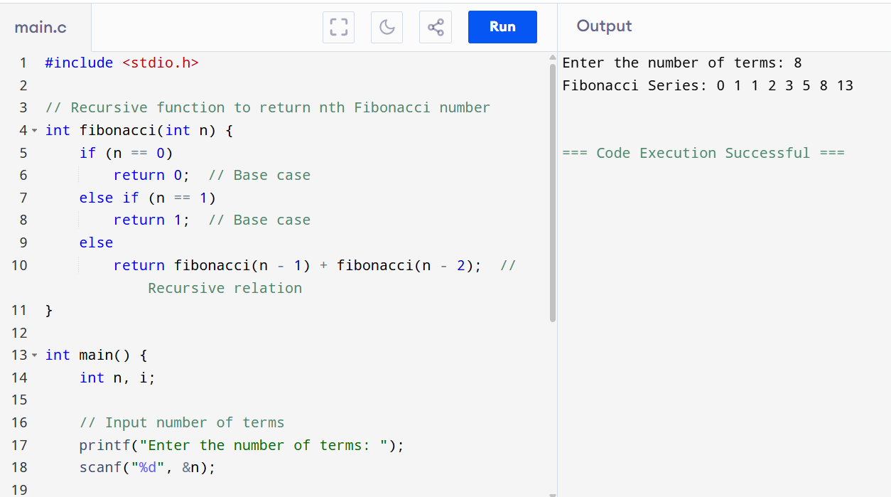

**OUTPUT**

Enter the number of terms: 8

Fibonacci Series: 0 1 1 2 3 5 8 13